**CHAPTER - 5**

**BLOCK DIAGRAM**

MODULE-2

MODULE-1

5V POWER SUPPLY

STEP DOWN TRANFORMER

(230VAC TO 12VAC)

MODULE-3

12V POWER SUPPLY

12V

5V

12V

5V

INDUCTIVE PROXIMITY SENOSR

MODULE-5

IR SENSOR

AT 89S52

DC MOTOR

MODULE-4.0

L298N DRIVER IC

DC MOTOR

5V

IR SENSOR

MODULE-4.1

MODULE-7.0

DC MOTOR

**CHA**

MODULE-4.2

IR SENSOR

5V

L298N DRIVER IC

DC MOTOR

MODULE-7.1

5V

MODULE-6

MODULE-8

**CHAPTER 6**

**INTERCONNECTION DIAGRAM**

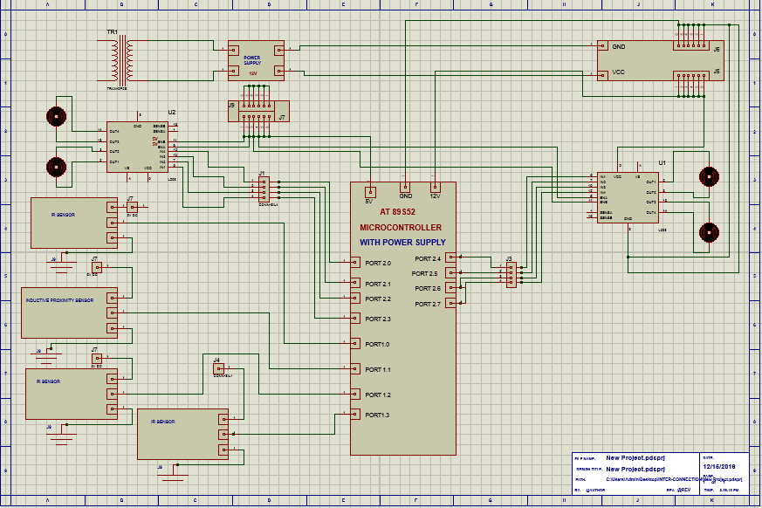

**CHAPTER 7**

**SCHEMATIC DIAGRAM**

